Graduation 2021 Parking Information

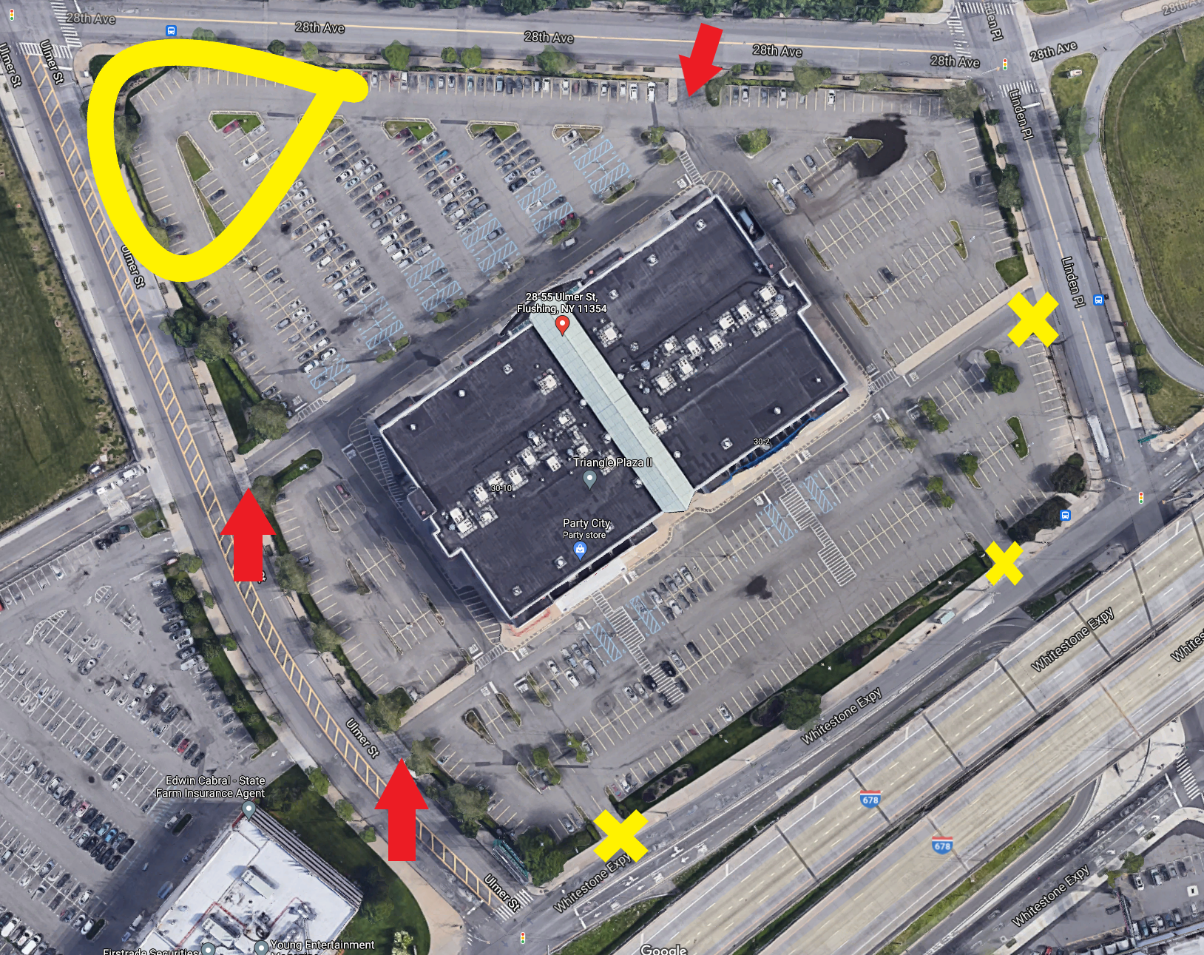
The area highlighted in yellow is where guests can park. It is located at the corner of Ulmer Street and 28th Avenue closest to Police Academy. The red arrows are locations for entering and exiting the site. These locations are located at:
-Ulmer street between Whitestone Expressway and 28th Avenue
-28th Avenue between Ulmer Street and Linden Pl.

Locations noted in a YELLOW X are not ideal for entering and exiting. Current security and construction limit access and exiting throughout the day.

